Pandas-Challenge

*Written description of at least two observable trends based on the data:*

**Observable Trend One: Size Summary**

Based on the data, small (<1000) and medium (1000-2000) schools outperformed large schools (2000-5000).

For overall passing rates, medium-sized schools ranked first with a total overall passing percentage of 90.62%, while smaller schools followed closely with 89.88%. In contrast, larger schools had a significantly lower overall passing rate of 58.28%.

In terms of average Math and Reading Scores, small and medium schools performed similarly, with both scoring in the 83rd percentile for math and reading. Larger schools, however, scored lower, with 77.74% in Math Scores and 81.34% in Reading Scores. This indicates that students in smaller schools tend to perform better academically.

From this data, it is evident that the smaller the school size, the better the students tend to perform. Medium and small schools showed only a tenth of a percentile difference across the measured metrics, whereas larger schools lagged by several percentage points, with an overall passing rate nearly 40% lower at 58.28% compared to the 89.88% and 90.62% of smaller and medium-sized schools.

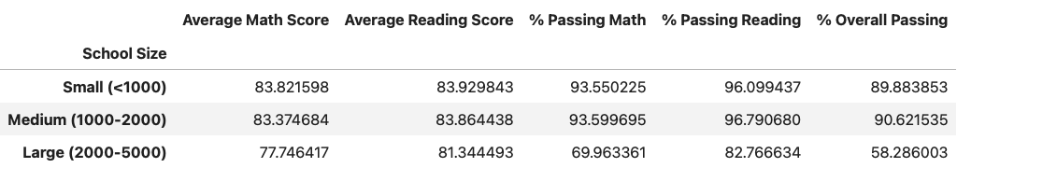

***Observable Trend Two: Spending Summary***

Based on the data, there is a clear trend that higher spending per student does not necessarily correlate with better academic performance.

For schools spending less than $585 per student, the average Math Score is 83.46, and the average Reading Score is 83.93. These schools also have high passing rates, with 93.46% passing Math and 96.61% passing Reading, resulting in an overall passing rate of 90.37%.

Schools spending between $585 and $630 per student have slightly lower average scores, with an average Math Score of 81.90 and an average Reading Score of 83.16. The passing rates are also lower, with 87.13% passing Math and 92.72% passing Reading, leading to an overall passing rate of 81.42%.

For schools in the $630 to $645 spending range, the average Math Score drops to 78.52, and the average Reading Score to 81.62. The passing rates are 73.48% for Math and 84.39% for Reading, resulting in an overall passing rate of 62.86%.

Schools with the highest spending range of $645 to $680 per student have the lowest average scores, with an average Math Score of 77.00 and an average Reading Score of 81.03. The passing rates are 66.16% for Math and 81.13% for Reading, leading to an overall passing rate of 53.53%.

From this data, it can be observed that schools with lower spending per student tend to have higher academic performance and passing rates compared to schools with higher spending per student.

